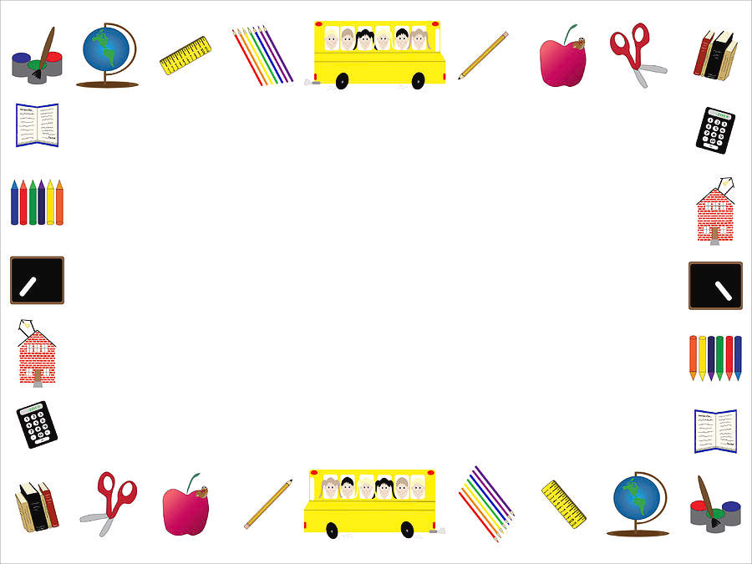

Second Grade Supply List

$20 for field trips and activities

Hand Sanitizer

Kleenex

Head phones NOT ear buds

Black Sharpies

Clorox Wipes